**Configuring a Basic Spring Application**

**Scenario:**

Your company is developing a web application for managing a library. You need to use the Spring Framework to handle the backend operations.

**Objective:**

To set up a basic Spring application using XML configuration, enabling loose coupling between components like BookService and BookRepository using Spring's IoC container.

**Program:**

applicationContext.xml

path: src/main/resources/applicationContext.xml

<?xml version="1.0" encoding="UTF-8"?>

<beans xmlns="http://www.springframework.org/schema/beans"

xmlns:xsi="http://www.w3.org/2001/XMLSchema-instance"

xsi:schemaLocation="http://www.springframework.org/schema/beans

http://www.springframework.org/schema/beans/spring-beans.xsd">

<bean id="bookRepository" class="com.library.repository.BookRepository" />

<bean id="bookService" class="com.library.service.BookService">

<property name="bookRepository" ref="bookRepository" />

</bean>

</beans>

pom.xml

<project xmlns="http://maven.apache.org/POM/4.0.0" xmlns:xsi="http://www.w3.org/2001/XMLSchema-instance" xsi:schemaLocation="http://maven.apache.org/POM/4.0.0 https://maven.apache.org/xsd/maven-4.0.0.xsd">

<modelVersion>4.0.0</modelVersion>

<groupId>com.library</groupId>

<artifactId>LibraryManagement</artifactId>

<version>0.0.1-SNAPSHOT</version>

<dependencies>

<dependency>

<groupId>org.springframework</groupId>

<artifactId>spring-context</artifactId>

<version>5.3.34</version>

</dependency>

</dependencies>

</project>

BookRepository.java

Path: src/main/java/com/library/repository/BookRepository.java

package com.library.repository;

public class BookRepository {

public void saveBook() {

System.***out***.println("Book saved successfully!");

}

}

BookService.java

Path: src/main/java/com/library/service/BookService.java

package com.library.service;

import com.library.repository.BookRepository;

public class BookService {

private BookRepository bookRepository;

public void setBookRepository(BookRepository bookRepository) {

this.bookRepository = bookRepository;

}

public void addBook() {

System.***out***.println("Service: Adding book...");

bookRepository.saveBook();

}

}

App.java

Path: src/main/java/com/library/App.java

package com.libraryApp;

import org.springframework.context.ApplicationContext;

import org.springframework.context.support.ClassPathXmlApplicationContext;

import com.library.service.BookService;

public class App {

public static void main(String[] args) {

ApplicationContext context =

new ClassPathXmlApplicationContext("applicationContext.xml");

BookService bookService = context.getBean("bookService", BookService.class);

bookService.addBook();

}

}

**Output:**

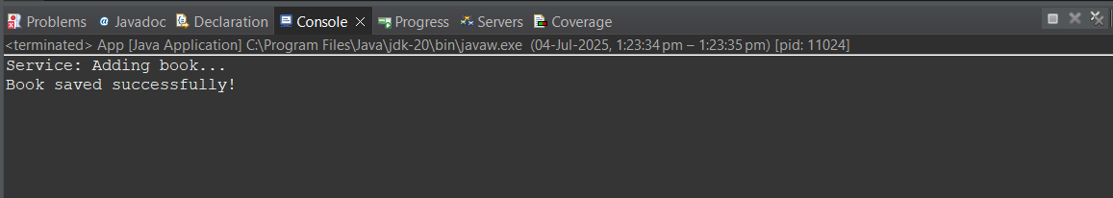

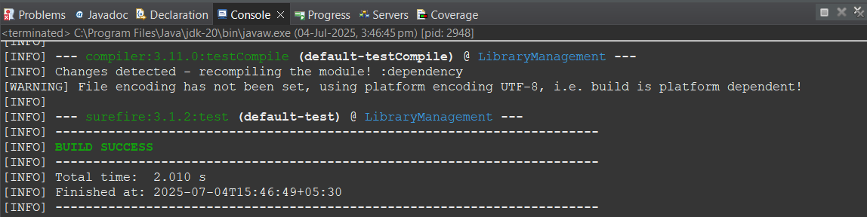

**Implementing Dependency Injection**

**Scenario:**

In the library management application, you need to manage the dependencies between the BookService and BookRepository classes using Spring's IoC and DI.

**Objective:**

To enhance the LibraryManagement application by implementing **setter-based Dependency Injection (DI)** using Spring's Inversion of Control (IoC) container.

**Program:**

Pom.xml

<project xmlns="http://maven.apache.org/POM/4.0.0" xmlns:xsi="http://www.w3.org/2001/XMLSchema-instance" xsi:schemaLocation="http://maven.apache.org/POM/4.0.0 https://maven.apache.org/xsd/maven-4.0.0.xsd">

<modelVersion>4.0.0</modelVersion>

<groupId>com.library</groupId>

<artifactId>LibraryManagement</artifactId>

<version>0.0.1-SNAPSHOT</version>

<dependencies>

<!-- Spring Core Context -->

<dependency>

<groupId>org.springframework</groupId>

<artifactId>spring-context</artifactId>

<version>5.3.34</version>

</dependency>

<!-- Spring AOP -->

<dependency>

<groupId>org.springframework</groupId>

<artifactId>spring-aop</artifactId>

<version>5.3.34</version>

</dependency>

<!-- Spring Web MVC (optional for now) -->

<dependency>

<groupId>org.springframework</groupId>

<artifactId>spring-webmvc</artifactId>

<version>5.3.34</version>

</dependency>

</dependencies>

<properties>

<maven.compiler.source>1.8</maven.compiler.source>

<maven.compiler.target>1.8</maven.compiler.target>

</properties>

<build>

<plugins>

<!-- Compiler Plugin -->

<plugin>

<groupId>org.apache.maven.plugins</groupId>

<artifactId>maven-compiler-plugin</artifactId>

<version>3.11.0</version>

<configuration>

<source>1.8</source>

<target>1.8</target>

</configuration>

</plugin>

</plugins>

</build>

</project>

BookService.java

Path: src/main/java/com/library/service/BookService.java

package com.library.service;

import com.library.repository.BookRepository;

public class BookService {

private BookRepository bookRepository;

private String serviceName;

//setter injection

public void setBookRepository(BookRepository bookRepository) {

this.bookRepository = bookRepository;

}

public void addBook() {

System.***out***.println("Service: Adding book...");

bookRepository.saveBook();

}

}

**Output:**



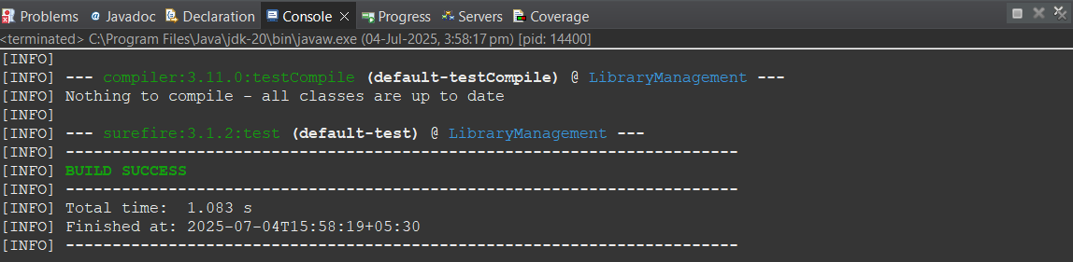

**Configuring the Spring IoC Container and Implementing Constructor and Setter Injection**

<?xml version="1.0" encoding="UTF-8"?>

<beans xmlns="http://www.springframework.org/schema/beans"

xmlns:xsi="http://www.w3.org/2001/XMLSchema-instance"

xsi:schemaLocation="http://www.springframework.org/schema/beans

http://www.springframework.org/schema/beans/spring-beans.xsd">

<bean id="bookRepository" class="com.library.repository.BookRepository" />

<bean id="bookService" class="com.library.service.BookService">

<constructor-arg value="Library Book Service" />

<property name="bookRepository" ref="bookRepository" />

</bean>

</beans>

package com.library.service;

import com.library.repository.BookRepository;

public class BookService {

private BookRepository bookRepository;

private String serviceName;

//Constructor injection

public BookService(String serviceName) {

this.serviceName = serviceName;

System.***out***.println("Constructor Injection: serviceName = " + serviceName);

}

//setter injection

public void setBookRepository(BookRepository bookRepository) {

this.bookRepository = bookRepository;

}

public void addBook() {

System.***out***.println("Service: Adding book...");

bookRepository.saveBook();

}

}

**Output:**

